Spectral coherence: AUDUSD and USDCHF
Method 21 / daily log returns / Welch magnitude-squared coherence / Alpari D1 full available history

Study setup
Logical pair: AUDUSD , USDCHF
Broker symbols: AUDUSD_i , USDCHF_i
Snapshot: 2026-11-03_majors_alpari_D1
Timeframe: D1
Matched return window: 1999-01-05 to 2026-11-02 (UTC bar dates)
Matched return count n: 7200
Dropped unfinished last bar dated 2026-11-03 UTC after a tick-volume check against the prior complete day.
Welch: fs=1.0, nperseg=256, noverlap=128, window=hann, detrend=constant
Headline: gamma^2 nearest f=1/5; also 1/21 and 1/63
Complete matched rows (Excel): AUDUSD-USDCHF_Spectral_D1.xlsx
Complete matched rows (HTML table): AUDUSD-USDCHF_Spectral_D1_data.html

Method carried forward
Magnitude-squared spectral coherence gamma^2(f) measures shared linear power between matched daily log returns of close, ln(close_t / close_t-1), at each frequency f (cycles per day). Quotes are not inverted. Welch settings are frozen: fs=1, nperseg=256, noverlap=128, window=hann, detrend=constant. Headline is gamma^2 at the frequency bin nearest f=1/5 (five-day cycle from the formula sheet). Also reported: gamma^2 nearest f=1/21 and f=1/63, mean gamma^2 over the frequency grid, and phase of the cross-spectrum at the 1/5 bin. Coherence is unsigned (0 to 1); phase carries timing. Same-sample Pearson r is a side check only. This is not causation and not a trading signal.

Results (headline)
gamma^2 near 1/5: 0.077791
bin f (1/5): 0.199219
phase at 1/5 (rad): 2.445277
gamma^2 near 1/21: 0.278876
gamma^2 near 1/63: 0.330602
mean gamma^2: 0.179845
Pearson r: -0.380878

Target-frequency summary
period | target_f | f_bin | gamma2 | phase_rad
5 | 0.2 | 0.19921875 | 0.07779134 | 2.4452774
21 | 0.04761905 | 0.046875 | 0.27887629 | -3.1260957
63 | 0.01587302 | 0.015625 | 0.33060212 | 3.0454563

Conclusion
Headline gamma^2 near f=1/5 for AUDUSD and USDCHF: 0.0778 (bin f=0.199219, phase=2.4453 rad). At ~1/21: 0.2789; at ~1/63: 0.3306. Mean gamma^2 = 0.1798. Pearson r = -0.3809. This is frequency-domain linkage, not a trading signal.

Charts
Daily closes

Daily log returns

Spectral coherence gamma^2(f)
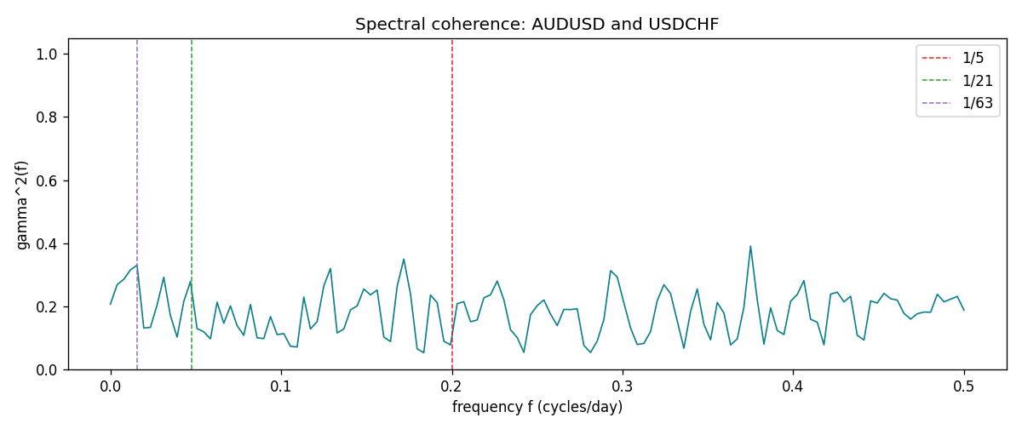

Data report
Matched rows and the coherence sheet are in the sibling Excel workbook named AUDUSD-USDCHF_Spectral_D1.xlsx. Embedding all rows as a Word table is impractical; this file holds column summaries and the first and last 15 matched rows.
Columns: time, AUDUSD_open, USDCHF_open, AUDUSD_high, USDCHF_high, AUDUSD_low, USDCHF_low, AUDUSD_close, USDCHF_close, AUDUSD_tick_volume, USDCHF_tick_volume, AUDUSD_spread, USDCHF_spread, AUDUSD_real_volume, USDCHF_real_volume, AUDUSD_log_return, USDCHF_log_return
Column summaries (matched calculation rows)
column | count | mean | std | min | 25% | 50% | 75% | max
AUDUSD_open | 7200 | 0.7519587 | 0.13528421 | 0.4785 | 0.6610975 | 0.731415 | 0.8091275 | 1.10284
USDCHF_open | 7200 | 1.0982244 | 0.25258622 | 0.72022 | 0.920675 | 0.990175 | 1.238625 | 1.8219
AUDUSD_high | 7200 | 0.75601148 | 0.13584385 | 0.4878 | 0.6647 | 0.734785 | 0.8152525 | 1.10795
USDCHF_high | 7200 | 1.1035234 | 0.25433538 | 0.73305 | 0.9249475 | 0.99377 | 1.2436 | 1.8313
AUDUSD_low | 7200 | 0.74790307 | 0.1345988 | 0.4775 | 0.65778 | 0.727495 | 0.804225 | 1.0975
USDCHF_low | 7200 | 1.0930985 | 0.25099871 | 0.08565 | 0.917415 | 0.98668 | 1.232725 | 1.8121
AUDUSD_close | 7200 | 0.75201172 | 0.13526687 | 0.4786 | 0.6612 | 0.731695 | 0.8091975 | 1.10169
USDCHF_close | 7200 | 1.0982149 | 0.25248642 | 0.72025 | 0.92097 | 0.990145 | 1.238625 | 1.8217
AUDUSD_tick_volume | 7200 | 77358.386 | 138142.18 | 109 | 5440 | 43334.5 | 71332.25 | 1234623
USDCHF_tick_volume | 7200 | 74199.562 | 113414.45 | 350 | 12776 | 40195 | 70261.25 | 858589
AUDUSD_spread | 7200 | 30.817222 | 16.887144 | 0 | 13 | 30 | 50 | 50
USDCHF_spread | 7200 | 26.104306 | 24.710129 | 0 | 5 | 16 | 50 | 100
AUDUSD_real_volume | 7200 | 5.2428187e+09 | 1.2538918e+11 | 0 | 0 | 0 | 0 | 3.811512e+12
USDCHF_real_volume | 7200 | 2.3239785e+10 | 8.9047261e+10 | 0 | 0 | 0 | 0 | 1.9331921e+12
AUDUSD_log_return | 7200 | 2.837e-05 | 0.00754598 | -0.08602525 | -0.00385535 | 0.0002835 | 0.00415437 | 0.0806166
USDCHF_log_return | 7200 | -7.168e-05 | 0.00659376 | -0.19545699 | -0.00336083 | 8.057e-05 | 0.00331954 | 0.09051364
First 15 matched rows (selected columns)
time | AUDUSD_log_return | USDCHF_log_return
1999-01-05 | -0.00080418179 | 0.0039424743
1999-01-06 | 0.011836351 | 0.013605652
1999-01-07 | 0.0088650256 | -0.0093883841
1999-01-08 | 0.00031515916 | 0.011040268
1999-01-11 | 0.0072213815 | 0.0052963193
1999-01-12 | -0.0048608485 | -0.0098275602
1999-01-13 | -0.0078902098 | -0.018259701
1999-01-14 | -0.002696916 | -0.0024256692
1999-01-15 | 0.007123101 | 0.01794228
1999-01-18 | 0.00094592471 | -0.0031856384
1999-01-19 | 0.0072225153 | -7.2518946e-05
1999-01-20 | 0.0012507819 | 0.0072259871
1999-01-21 | 0.00078094498 | -0.0038232689
1999-01-22 | -0.012252745 | -0.0001445609
1999-01-25 | -0.0039591468 | 0.0024546976
Last 15 matched rows (selected columns)
time | AUDUSD_log_return | USDCHF_log_return
2026-10-13 | 0.0035007712 | -0.0024955621
2026-10-14 | -0.0015193215 | 0.0029388325
2026-10-15 | -0.0075447063 | -0.0097855323
2026-10-16 | 0.0033906408 | -0.0036230826
2026-10-19 | 0.0050859986 | 0.0036351779
2026-10-20 | 0.0034620426 | -0.0026281224
2026-10-21 | 0.0036066384 | -0.00040027413
2026-10-22 | -0.0012672558 | -0.0048036381
2026-10-23 | 0.0023765656 | 0.005652514
2026-10-26 | -0.0032032829 | 0.0018407959
2026-10-27 | 0.0016669876 | 0.0026100526
2026-10-28 | 0.0040915541 | -0.0010142111
2026-10-29 | -0.0040915541 | -0.0048680164
2026-10-30 | 0.0010102376 | 0.00071594559
2026-11-02 | -0.0049184984 | -0.0071459744
First 15 frequency bins
f | gamma2 | phase_rad | period_days
0 | 0.20700053 | 3.1415927 | inf
0.00390625 | 0.26853891 | -3.0018069 | 256
0.0078125 | 0.28558676 | 3.1099608 | 128
0.01171875 | 0.31554138 | 3.0485364 | 85.333333
0.015625 | 0.33060212 | 3.0454563 | 64
0.01953125 | 0.13127977 | 2.8147231 | 51.2
0.0234375 | 0.13344991 | -3.0123481 | 42.666667
0.02734375 | 0.20458641 | 3.0531068 | 36.571429
0.03125 | 0.29215532 | 2.9307268 | 32
0.03515625 | 0.17064259 | 2.9534855 | 28.444444
0.0390625 | 0.10251751 | 3.1381881 | 25.6
0.04296875 | 0.21524868 | -2.8277917 | 23.272727
0.046875 | 0.27887629 | -3.1260957 | 21.333333
0.05078125 | 0.1293404 | 2.9055392 | 19.692308
0.0546875 | 0.11933638 | 3.0422007 | 18.285714

